

**OBJECT ORIENTED ANALYSIS AND DESIGN**

**PROJECT REPORT**

**PHARMACY MANAGEMENT SYSTEM**

|  |  |  |
| --- | --- | --- |
| **Name** | **Student Id** | **Class Id** |
| **M.Hammad Shaikh** | **14983** | **116476** |
| **Marium Haris** | **15084** | **116476** |

**Instructor: Sir Sohail Imran**

**Introduction**

The Pharmacy Management System (PMS) is designed to streamline the management of key records in a pharmacy. This includes customer records, employee details, medicine inventories, pharmacy branches, pharmacist records, prescriptions, and orders. The system provides a user-friendly interface for performing CRUD (Create, Read, Update, Delete) operations efficiently. The report outlines the design, use cases, and flow of this system.

**System Overview**

The PMS consists of:

1. A **Home Page** with navigation options.
2. A **Navbar** providing links to:
   * Home
   * About
   * Contact
3. Management buttons for:
   * Customer Records
   * Employee Records
   * Medicine Records
   * Pharmacy Branches
   * Pharmacist Records
   * Prescriptions
   * Orders

Each button directs the user to a specific module for managing records, allowing for CRUD operations integrated with the database.

**Diagrams Created:**

1. Use case diagram

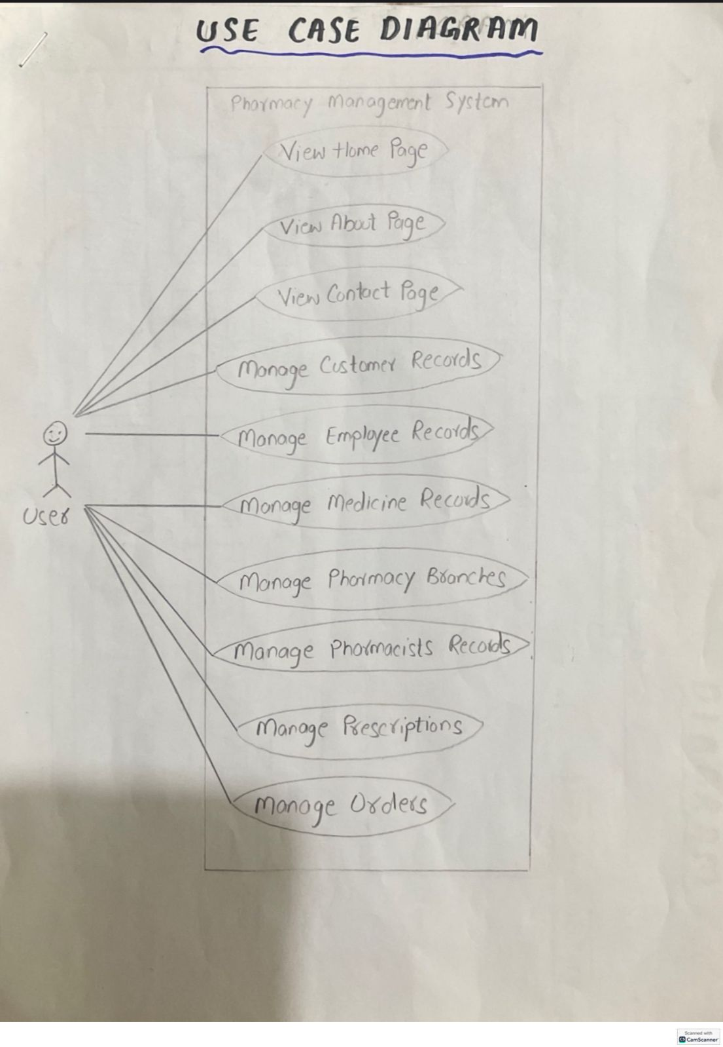

1. Use case narration
2. Sequence diagram

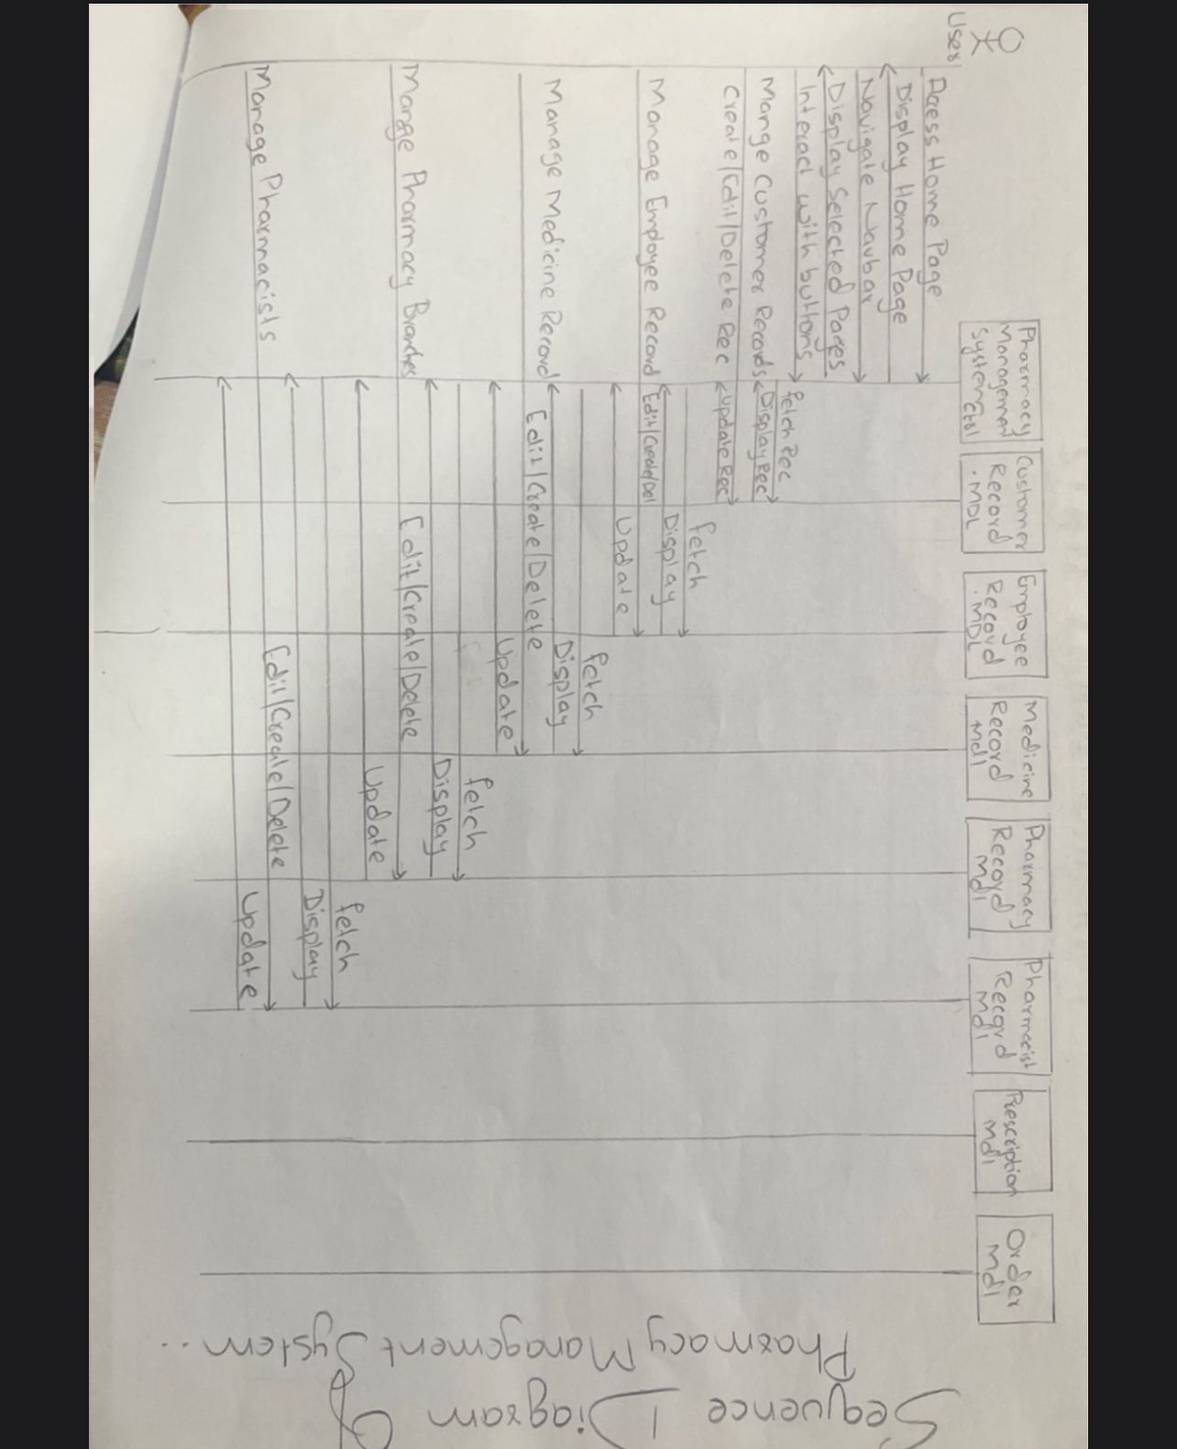

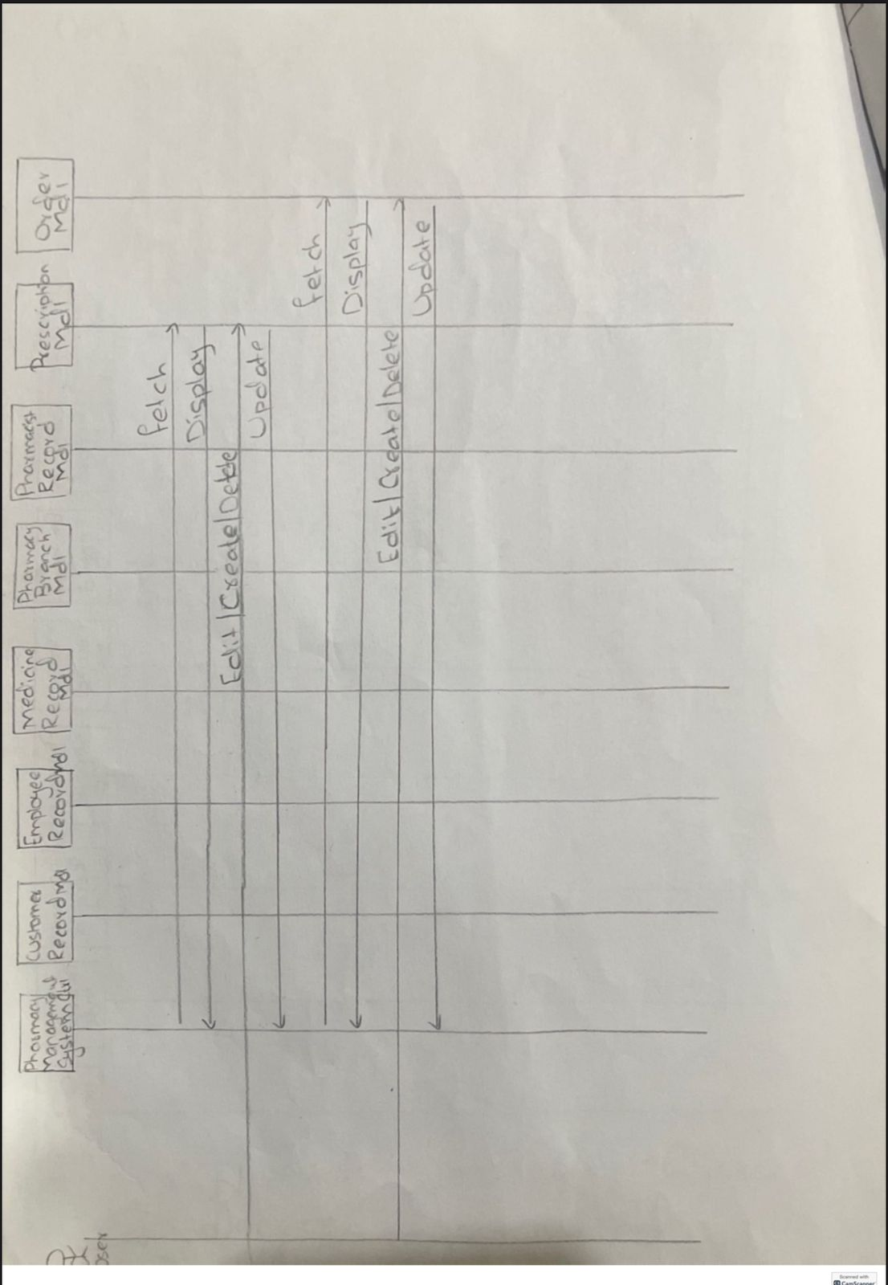

1. Class diagram

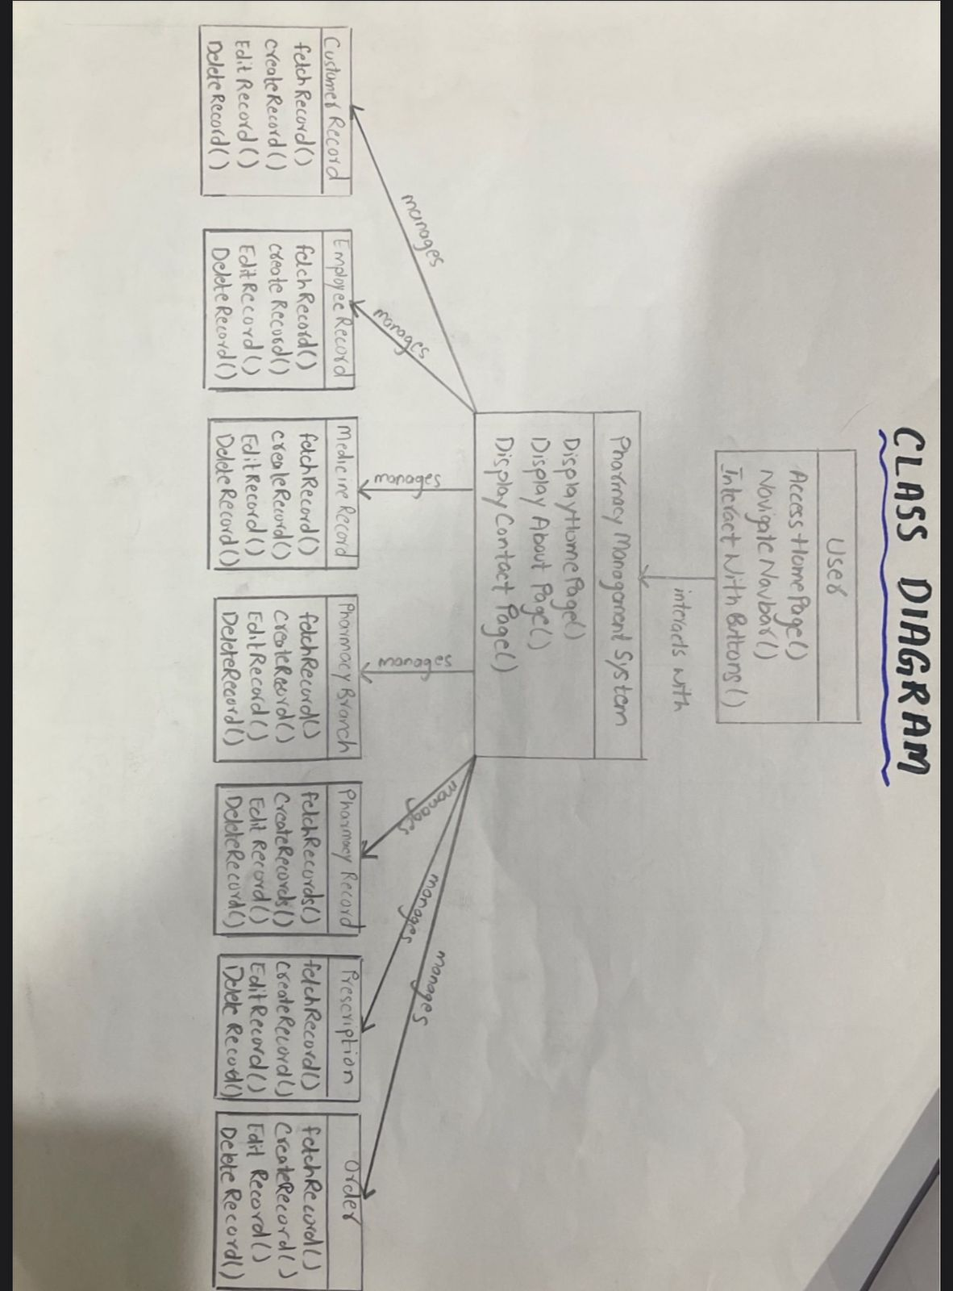

1. Activity diagram

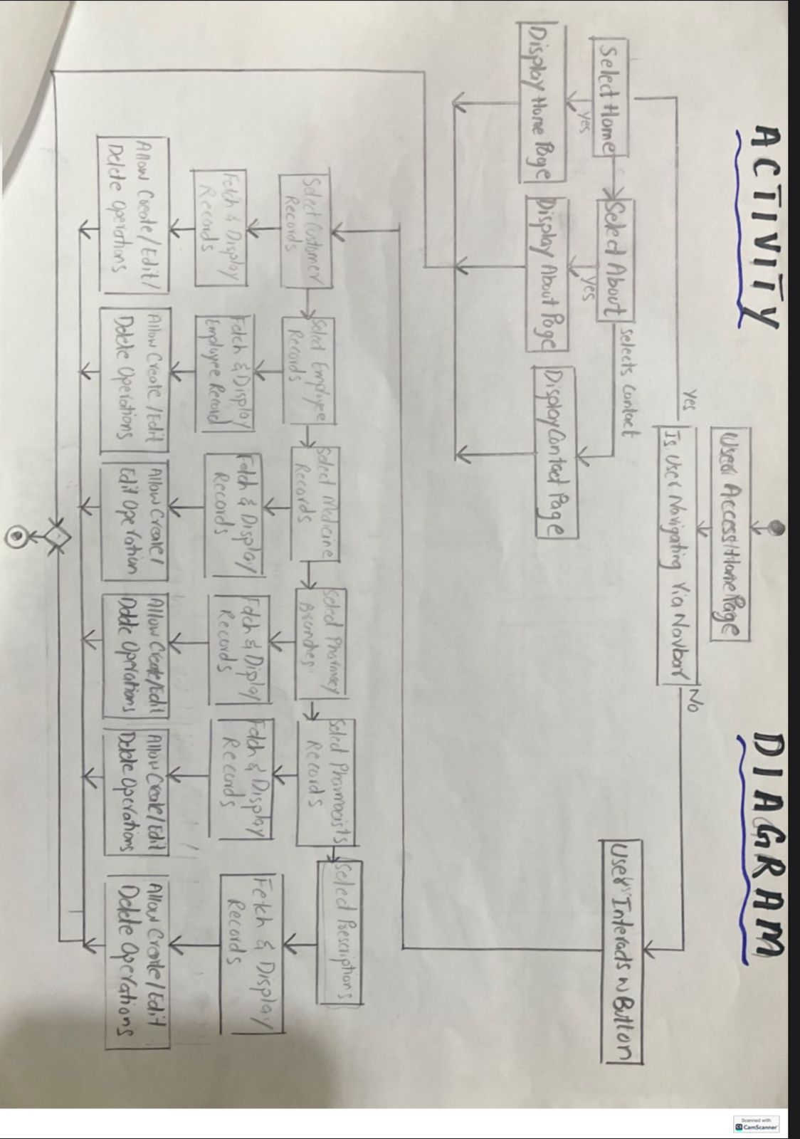

1. Collaboration diagram

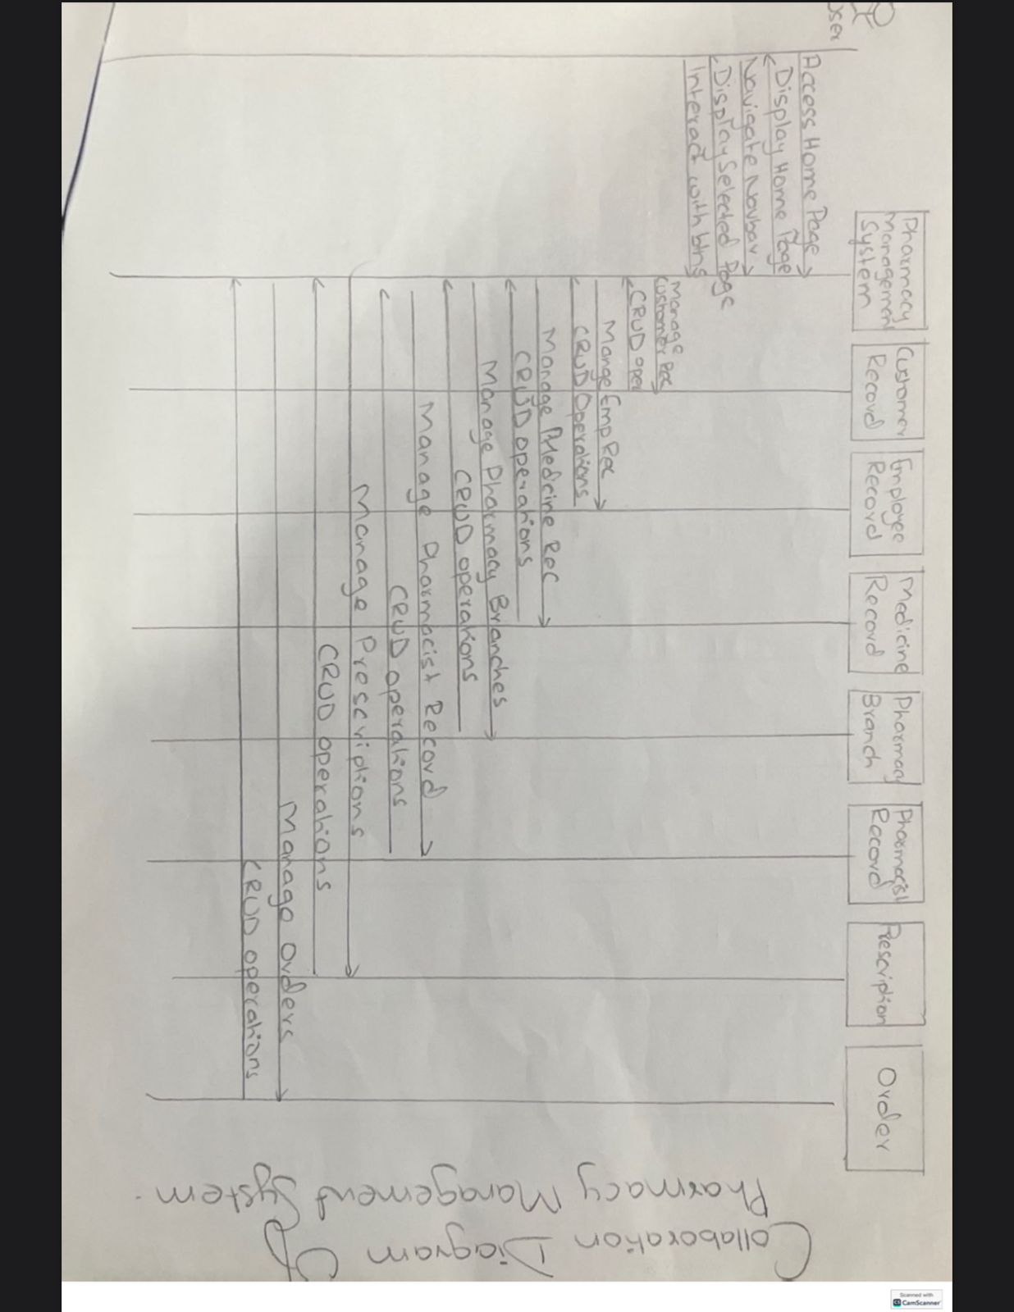

1. State chart diagram

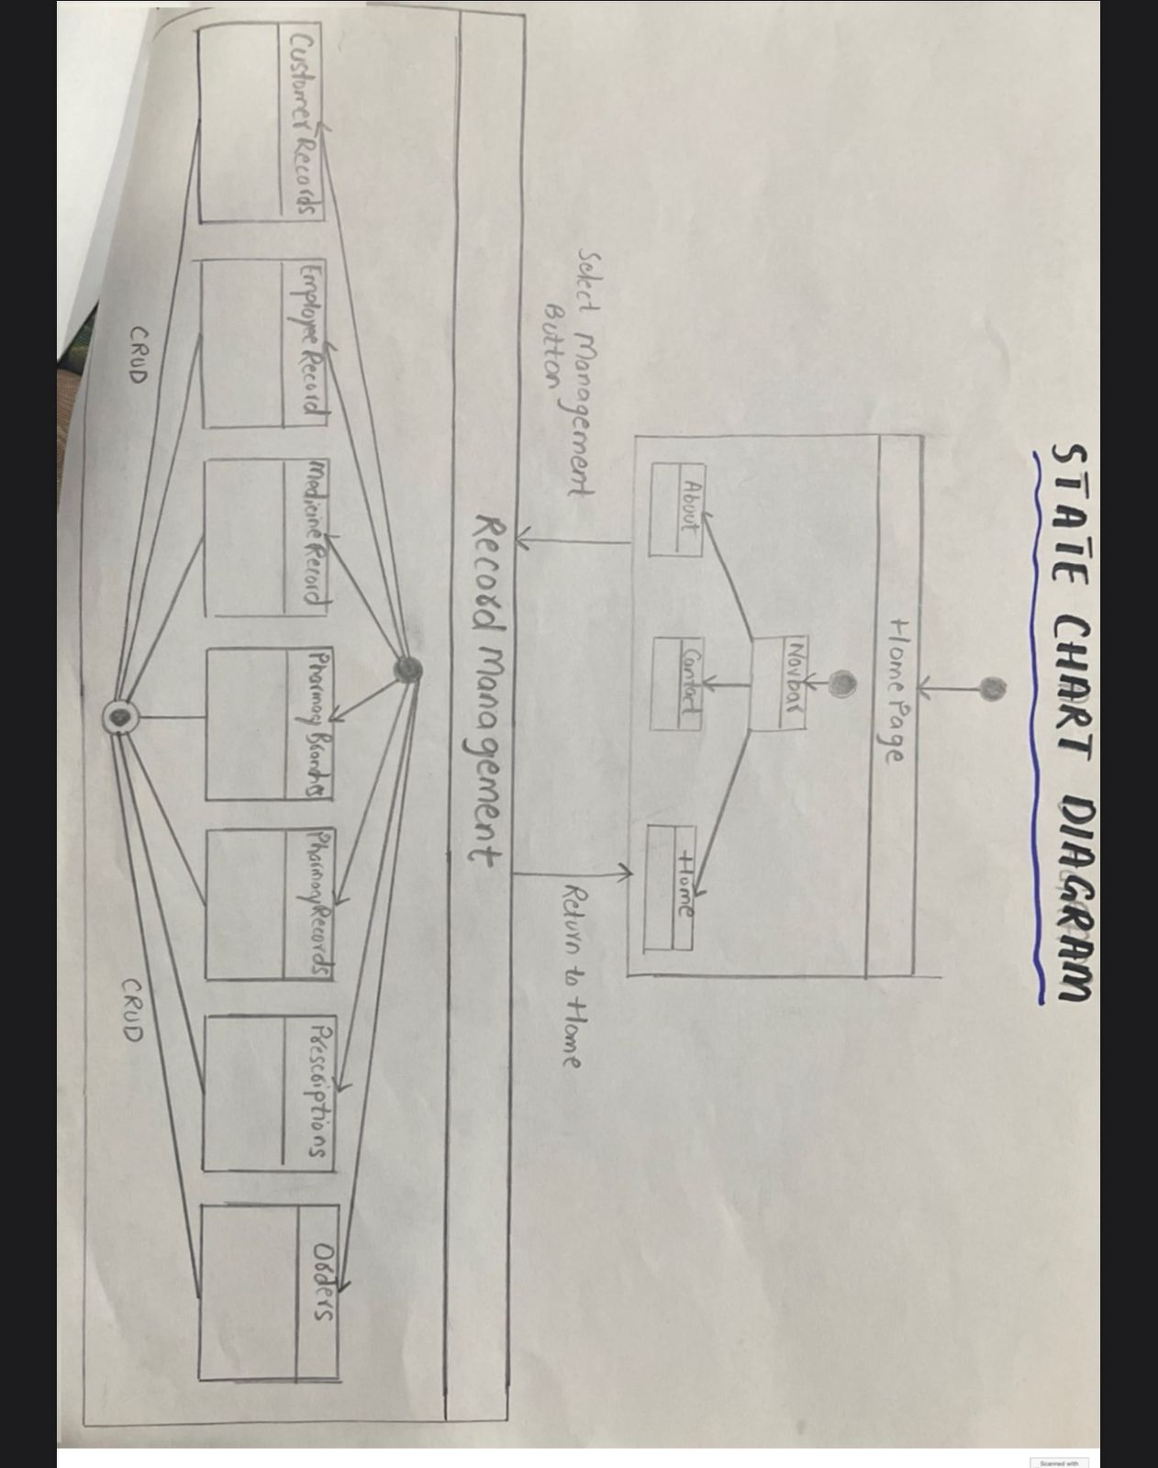

**Tools Used**

* **Visual Studio**: For developing the ASP.NET MVC project.
* **SQL Server Management Studio**: For creating and managing the database.
* **Clickup**: For project milestones and tasks
* **Somee.com: Live hosting**

**Skills Utilized**

* Programming Language: **C#**
* Framework: **.NET Framework**
* Database Management: **SQL**
* **Project Management: Clickup**

**PROJECT MANAGEMENT ON CLICKUP:**

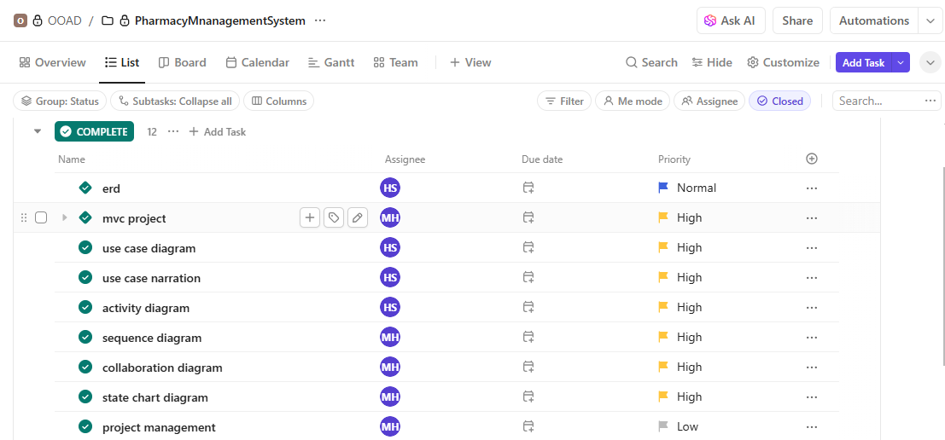

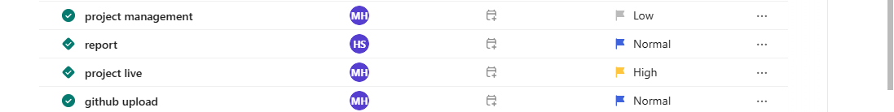

**LIVE HOSTING:**

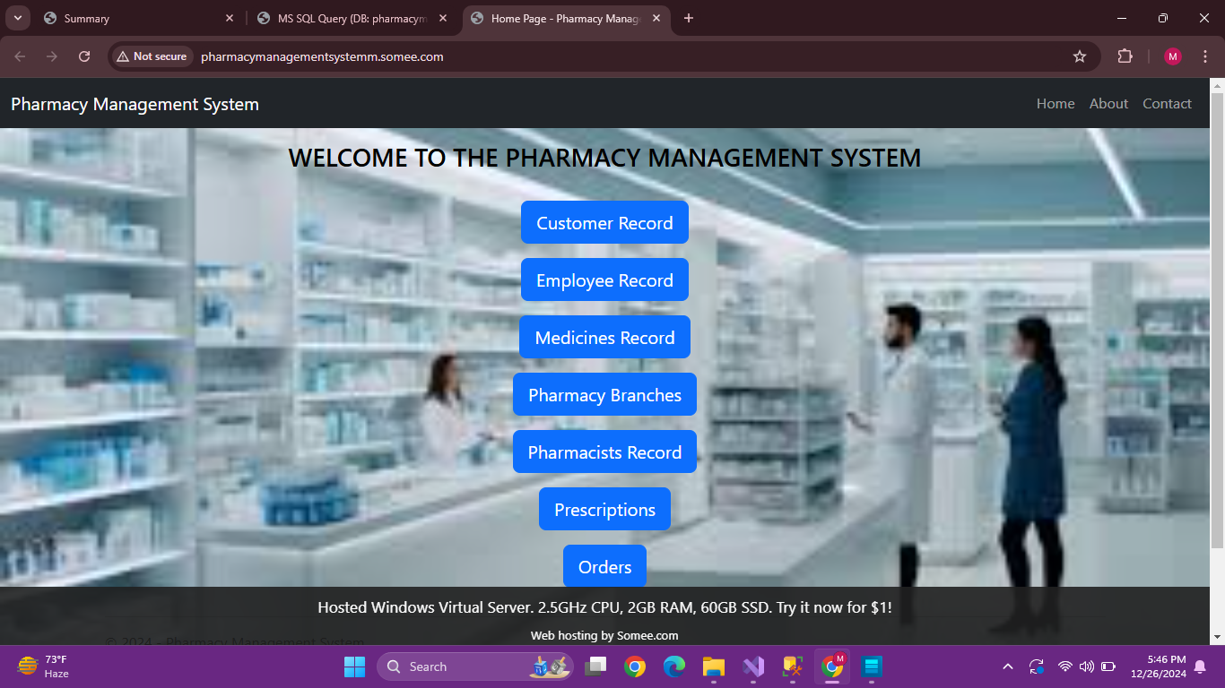

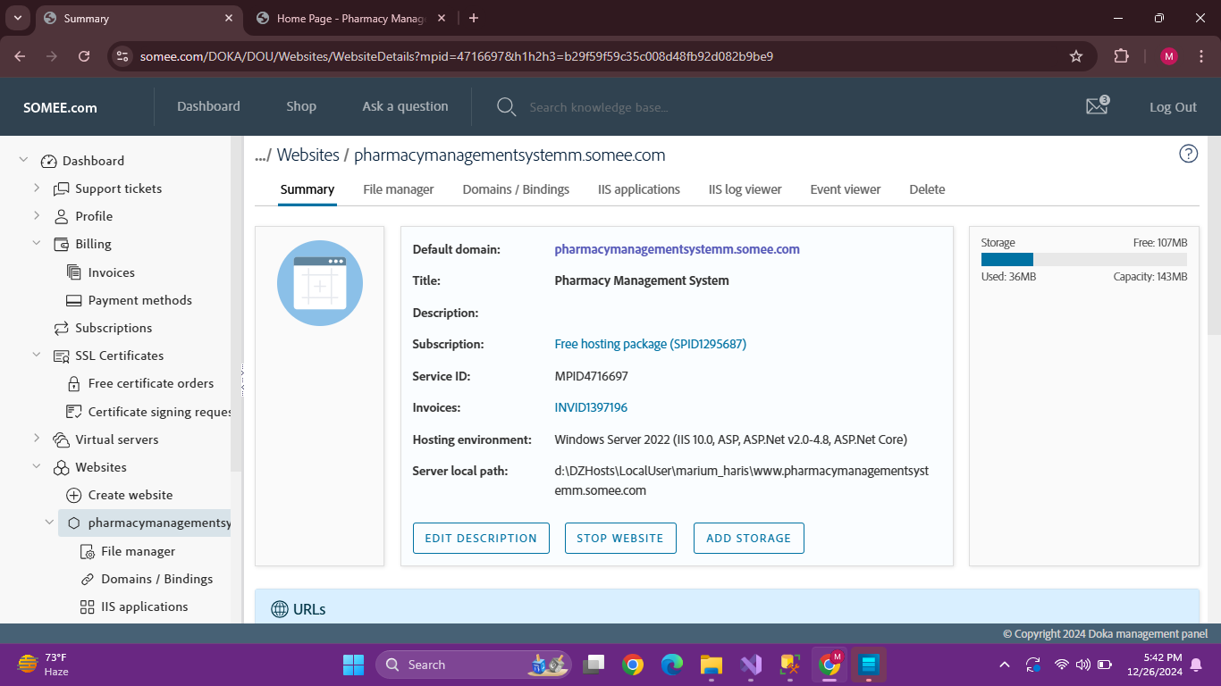

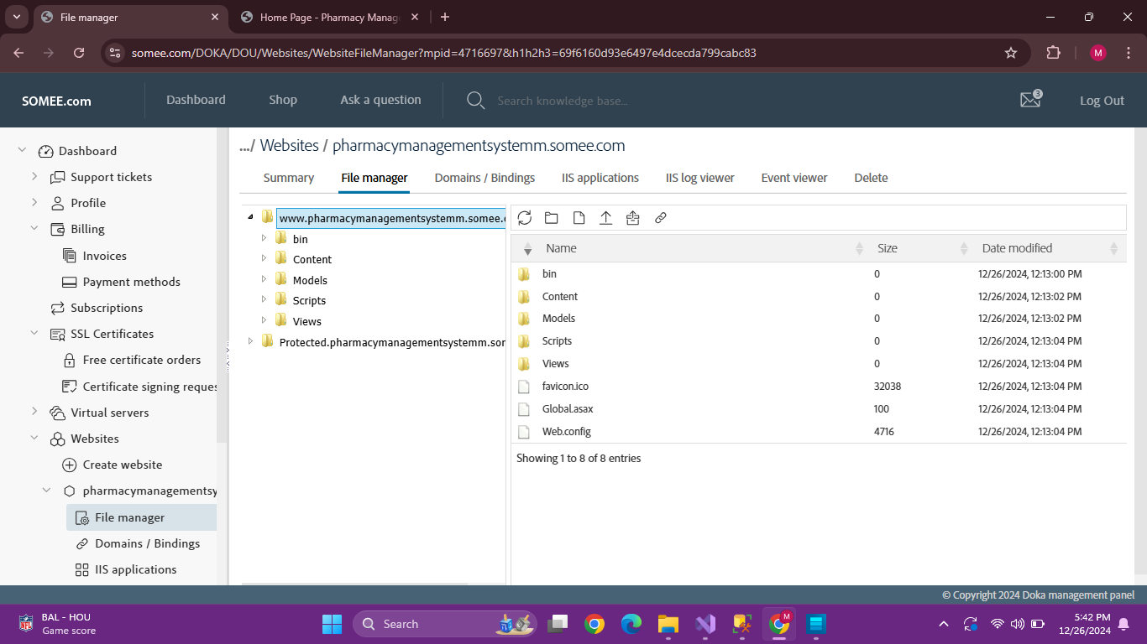

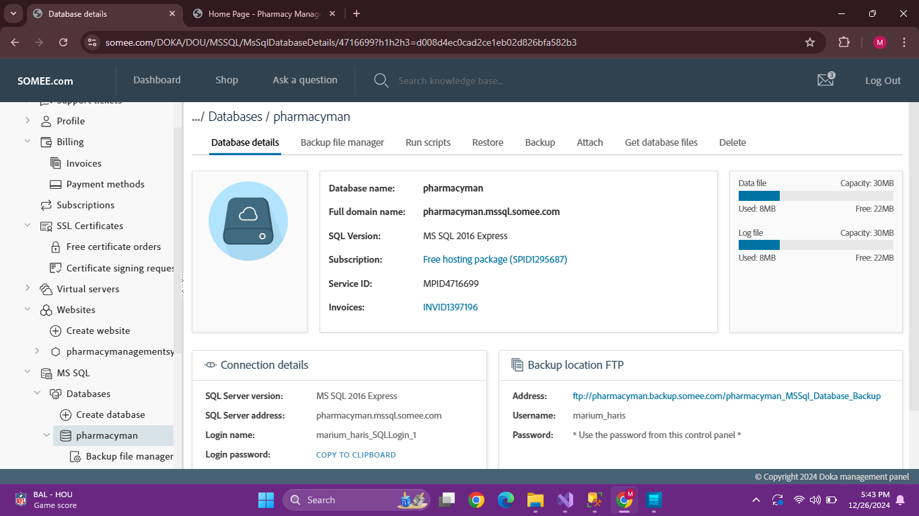

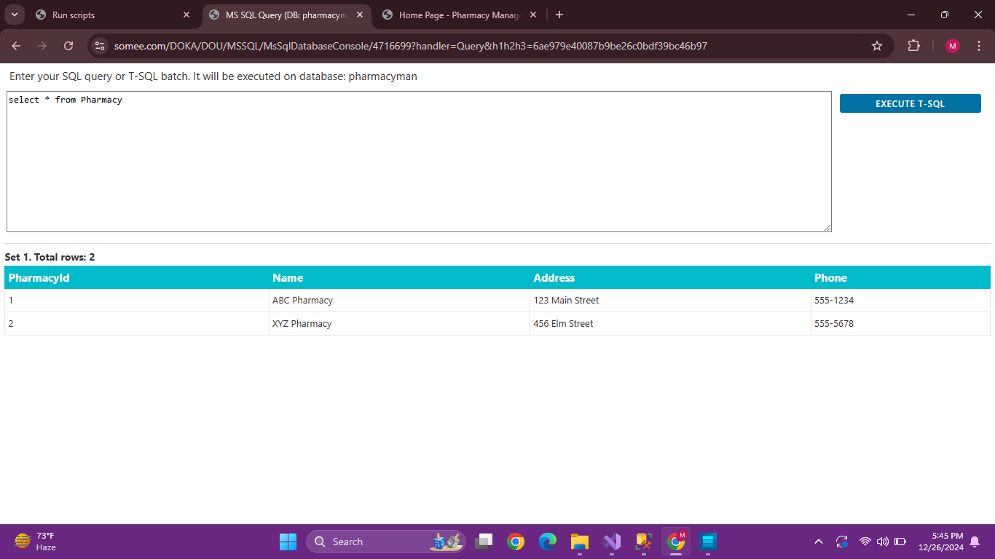

**Conclusion:**

The system ensures data consistency and user efficiency through clear navigation and robust CRUD functionalities. The design diagrams and use case narration serve as the foundation for implementing and enhancing this system further.